Model tiers
Tier | Pick it when | Signal words in the question
Haiku | Short, well-defined, high volume, speed matters, a human reviews the output | live call, real time, while the caller waits, classify, rephrase, extract
Sonnet | Everyday professional drafting, analysis, most coding | default, balanced, general work
Opus | Complex, ambiguous, multi-step reasoning; quality over speed | deep analysis, architecture, high stakes, no review step

client = get_client()
response = client.messages.create(
model=MODEL,
max_tokens=max_tokens,
system=system_prompt,
tools=[tool],
tool_choice=tool_choice,
messages=[{"role": "user", "content": user_text}],
)

https://dharni33.github.io/Claude-Certified-Architect-Exam/

Anthropic Academy, SDK, docs — all linked below
🆓 Interactive 3-week study plan → https://dharni33.githu...
🎓 Anthropic Academy (free courses) → anthropic.skilljar.com
📖 Claude documentation → docs.anthropic.com
⚙️ Anthropic SDK → github.com/anthropics/anthropic-sdk-python
🔧 MCP documentation → modelcontextprotocol.io
📗 Anthropic Cookbook → github.com/anthropics/anthropic-cookbook

https://www.cosx.ai/ccaf-guide/study-guide?lesson=domain-1-agentic-architecture-orchestration

Claude code build-in tools
- Read – open and read the file content, REQUIRED BEFOR EDIT AND WRITE
- EDIT – target change via unique anchor text , Anchor must match exactly once
- Write – Create and modify new file content, when Edit can't anchor
- Bash – Shall command execute npm, unittesting and scripts, Don't use it to replace Read/Grep/Edit
- Grep – scan multiple file + ripgrep to seach inside the file–ONLY CONTENT(FUN/ERROR/IMPORT)
- Glob – find file path and names, NOT THE CONTENT

PATH :
my-project/
├── .claude/
│ └── commands/
│ └── review.md
├── src/
├── tests/
└── package.json

.claude/commands/ → PROJECT → TEAM → Git – Added into GitHub
~/.claude/commands/ → USER → PERSONAL → your machine

Type | Typical location | Scope | Easy memory
Project commands | .claude/commands/ | Repository/team | 🏢 Team
Personal commands | ~/.claude/commands/ | Your account/machine | 👤 Me
Project memory | CLAUDE.md in project | Repository/team | 📖 Project rules
Personal memory | ~/.claude/CLAUDE.md | Your projects | 👤 My rules
Project settings | .claude/settings.json | Repository/team | ⚙️ Shared config
Local project settings | .claude/settings.local.json | You + this project | 🔒 Local config
User settings | ~/.claude/settings.json | Your Claude Code usage | 👤 Global config
Project Skills | .claude/skills/<skill>/SKILL.md | Repository/team | 🧠 Reusable project capability
Personal Skills | ~/.claude/skills/<skill>/SKILL.md | Your account | 🧠 Personal capability

(CCAR-F): Quick Reference

Claude API: stop_ reason
Every response carries a stop_reason telling you why model generation halted. For agent loops, the
tool_use vs end_turn distinction is what drives the loop.

- end_turn — Claude has finished; surface the reply to the user.
- tool_use — Claude wants a tool run; execute it and feed the result back.
- max_tokens — the output cap was hit; the reply is truncated, so consider raising the limit.
- stop_sequence — a configured stop string was encountered.

EXAMPLE CHAT GPT –
Single Agentic Loop
https://chatgpt.com/share/6ab0baad-a6e4-83eb-af48-79085fab045f

https://youtu.be/b42eoAd0v40?t=592

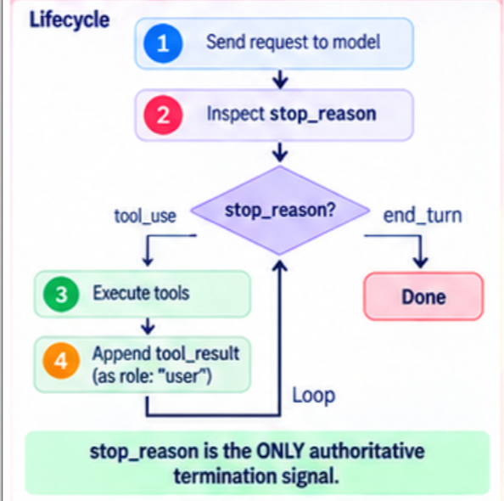

In the Claude API and agentic systems, the agentic loop is governed by explicit control signals returned in the API response rather than parsing output text.

Core Terms
- stop_reason: An enum field in Claude's API response that explicitly tells your application code why the model stopped generating output. Checking stop_reason is the primary way your code determines what action to take next in the agentic loop.
- tool_use: A specific value for stop_reason. It indicates that Claude wants to invoke one or more defined tools because it requires information or actions it cannot perform on its own. Claude provides the tool name, arguments, and a unique tool use ID, but relies on your code harness to actually execute the tool.
- end_turn: The stop_reason value indicating that Claude has completed its response/reasoning for the turn and requires no further tool calls. This serves as the explicit termination signal to exit the loop.

The Agentic Loop Flow
An agentic loop consists of four repeating steps:
+-------------------------------------------------------------+
| 1. Send conversation history + tool definitions to Claude |
+-------------------------------------------------------------+
|
v
+-------------------------------------------------------------+
| 2. Receive response & check response.stop_reason |
+-------------------------------------------------------------+
/ \
if "tool_use" if "end_turn"
/ \
v v
+-----------------------------------+ +-------------------+
| 3. Append assistant message to | | Exit loop / return|
| history & execute tool(s) | | final answer |
+-----------------------------------+ +-------------------+
|
v
+-------------------------------------------------------------+
| 4. Append tool results as a user message & repeat loop |
+-------------------------------------------------------------+
- Send Context: Pass the accumulated conversation history and tool definitions to Claude.
- Check stop_reason:
  - If stop_reason == "tool_use": Claude is requesting tool execution.
  - If stop_reason == "end_turn": The task or turn is complete—break and exit the loop.
  - If stop_reason == "max_tokens": The response reached the maximum token limit (truncation, not completion).
- Execute Requested Tool(s):
  - First, append Claude's complete assistant response—including the tool_use blocks—to the conversation history. (Omitting the tool_use blocks will cause subsequent API requests to fail).
  - Execute the requested tool(s) in your application harness.
- Return Results & Loop:
  - Construct a tool_result block for each executed tool, matching the tool use ID 1:1.
  - Append these results back to the conversation history as a user role message. THIS IS IMPORTANT AS THE CLAUDE DON’T HAVE ANY HISTORY.
  - Repeat the cycle by sending the updated conversation history back to Claude.

Key Execution Rules & Anti-Patterns
- Do NOT parse natural language for completion: Searching response text for phrases like "task complete" or assuming the presence/absence of text signals completion are anti-patterns. Always use stop_reason == "end_turn".
- 1:1 ID Matching: Every tool_use block emitted by Claude must receive exactly one corresponding tool_result block with matching IDs.
- Handle Tool Errors as Feedback: If a tool execution fails, do not crash the application. Return the error details in the tool_result block with is_error=True inside a user message so Claude can read the error and try an alternative approach.
- Safety Backstops: Always set a maximum iteration cap as a safety backstop to prevent unbounded loops, while keeping end_turn as the primary stopping mechanism
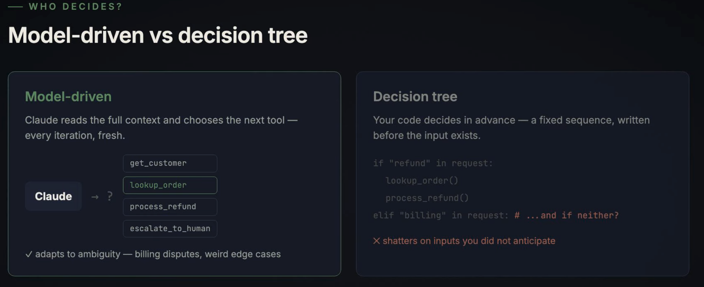

here claude decides what order should be called. there are two types of decision:
- model-driven which is decided by claude
- decision with the help of code
generally we prefer claude more. claude's decision tree is more ambiguous and adaptive in certain cases of billing dispute etc
Fixed sequence is always dangerous and causes a lot of problems

anti-patterns
three anti-patterns like
❌ Wrong approach | Why it’s wrong | ✅ Correct approach
Search Claude’s text for "done" | Natural-language text is not a reliable termination signal | Check stop_reason
Stop after an iteration limit | A limit such as 10 loops is only a safety guard | Use stop_reason as the normal control mechanism
Assume text output means finished | Claude can produce text and then request a tool | Inspect stop_reason even when text exists

stop_reason
│
├── end_turn → ✅ Claude finished normally
├── tool_use → 🔧 Execute tool → send result → continu
├── max_tokens → ⚠️ Output was cut off / token limit reached
├── stop_sequence → 🛑 Custom stop sequence triggered
├── pause_turn → 🔄 Continue/resume the interaction
└── refusal → 🚫 Inspect refusal/stop details

Multi Agent Orchestration
Hub & Spoke –

https://chatgpt.com/share/6ab0baad-a6e4-83eb-af48-79085fab045f

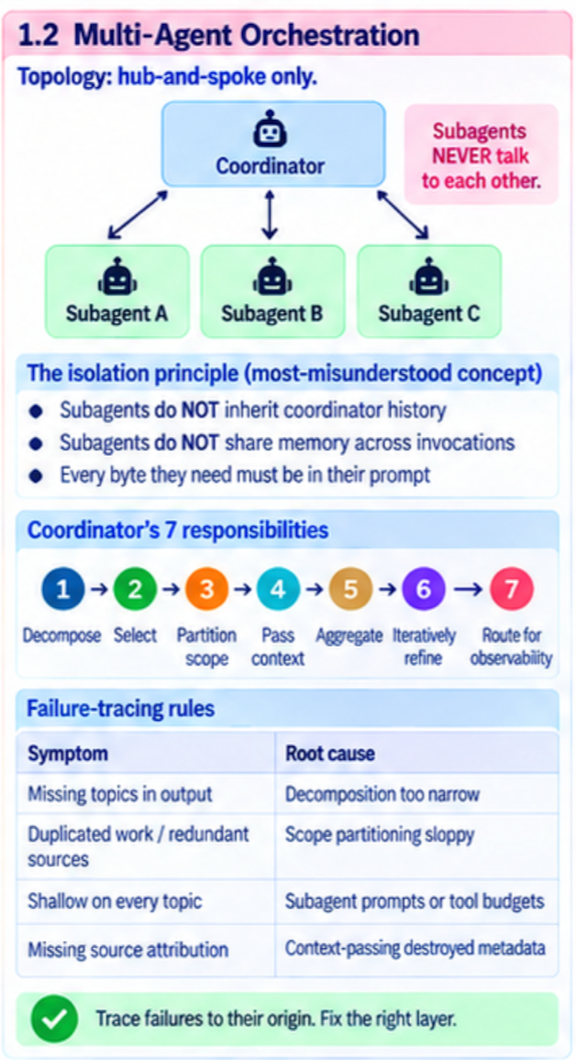 | 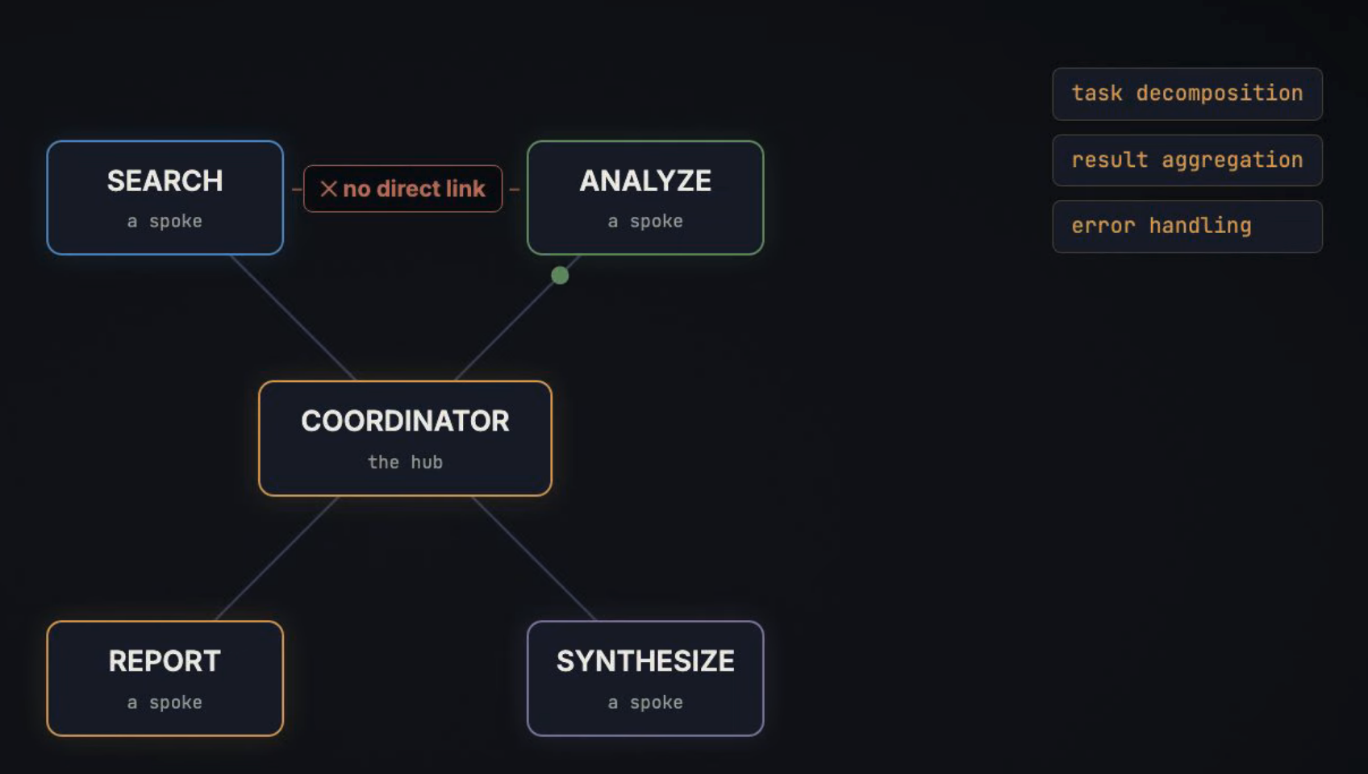

—— HOW TO SPAWN
The Task tool

# Subagent type
search_agent = AgentDefinition (
description="Searches the web for sources",
prompt="You are a research search agent...", ]
tools=["WebSearch", "WebFetch"],
)

# Coordinator MUST be allowed the Task tool
coordinator = AgentDefinition(
prompt="Goal: produce a cited report.."
allowedTools=["Task", “get_customer”,….], # * without this, no subagents
)

# Parallel: multiple Task calls
in ONE response, not across turns
Task(search_agent, query_a)
Task(search_agent, query_b# run side by side

The Spawning Mechanism: The coordinator uses the Task / Agent tool to delegate work to isolated subagent instances. [1, 2]

Spawning = launching a new isolated agent/sub-agent to handle a task.

- Coordinator Spawns Sub-Agents (task tool):
  - The coordinator uses the task tool to instantiate a sub-agent. (The coordinator's allowed_tools list must explicitly include task).
  - To run sub-agents in parallel (e.g., searching three sources at once), the coordinator emits multiple task tool calls in a single response turn.
- Coordinator Explicitly Injects Context into the Prompt:
  - Because the sub-agent cannot read the parent's memory, the coordinator must paste all relevant findings and context directly into the sub-agent's prompt payload.
  - Pass Complete Findings: Provide raw, complete findings rather than lossy summaries so the sub-agent has full context to work with.
  - Structure Content with Metadata: Include metadata (source URLs, document names, page numbers) alongside the text so downstream sub-agents (like a synthesis or reporting agent) can maintain precise attribution.
- Sub-Agent Executes and Returns:
  - The sub-agent runs in its isolated context window using its own restricted tool set.
  - Once finished, it returns its result only to the coordinator. Sub-agents never communicate directly with each other.
- Coordinator Aggregates and Delegates:
  - The coordinator receives the sub-agent's result, evaluates if research goals are met, and decides whether to refine, re-delegate, or assemble the final answer for the user.

Here are the JSON structures for the input (coordinator spawning a sub-agent) and output (sub-agent returning results to the coordinator), as well as the JSON Schema definition for registering the task tool.

1. PASSING CONTEXT to SUB AGENT using task_tool
When the coordinator decides to delegate work using the task tool, it emits a tool_use block inside its assistant message turn. The coordinator explicitly injects all necessary context, metadata, and quality criteria directly into the input payload:
{
"type": "tool_use",
"id": "toolu_01A2B3C4D5E6",
"name": "task",
"input": {
"subagent_type": "synthesis_agent",
"task_objective": "Synthesize security findingsstructured summary attribution.",
"allowed_tools": [],
"injected_context": {
"user_query": "What are the key security vulnerabilities Q3 audit reports?",
"complete_findings": [
{
"source_url": "https://internal.docs/audit-q3-net.pdf",
"document_title": "Network Security Audit Q3",
"page_number": 14,
"content": "Unencrypted telemetry endpoints detected on port 8080."
},

]
}
}
}
- subagent_type: Selects the specialized role definition and system prompt.
- allowed_tools: Scopes tool access for least-privilege execution (e.g., empty array for pure synthesis).
- injected_context: Explicitly passes raw, complete findings and structured source metadata so attribution is preserved without context inheritance.

2. Output JSON Payload: Sub-Agent Returning Results (tool_result)
Once the sub-agent completes its isolated loop, the host harness packages its result into a tool_result content block and appends it back to the coordinator in a single user role message:
Successful Completion
{
"role": "user",
"content": [
{
"type": "tool_result",
"tool_use_id": "toolu_01A2B3C4D5E6",
"content": JSON.stringify({
"status": "success",
"deliverable": {
"summary": "Two major vulnerabilities were flagged in the Q3 audits: unencrypted network traffic and over-privileged IAM accounts.",
"citations": [
{
"fact": "Unencrypted telemetry endpoints on port 8080.",
"source_url": "https://internal.docs/audit-q3-net.pdf",
"page_number": 14
},
]
}
})
}
]
}
Failed Sub-Agent Task (Error Handling)
If a sub-agent tool call fails, set is_error: true with an instructive message so the coordinator can re-delegate or adapt:
{
"role": "user",
"content": [
{
"type": "tool_result",
"tool_use_id": "toolu_01A2B3C4D5E6",
"is_error": true,
"content": "Search sub-agent failed: Internal query API timeout after 30s. Retry with narrowed date filter."
}
]
}
- tool_use_id: Must match the original tool_use.id exactly (1:1 matching).
- is_error: Flags execution errors so the coordinator handles failure as feedback rather than a crash.

3. JSON Schema Definition: Registering the task Tool
For a coordinator to invoke sub-agents, its registered tools array must include the definition for the task tool:
{
"name": "task",
"description": "Spawns a specialized sub-agent with an isolated context window to execute a dedicated sub-task. Pass complete raw findings and source metadata in injected_context.",
"input_schema": {
"type": "object",
"properties": {
"subagent_type": {
"type": "string",
"enum": ["search_agent", "document_analysis_agent", "synthesis_agent"],
"description": "The specific sub-agent role to instantiate."
},
"task_objective": {
"type": "string",
"description": "Clear research goals and quality criteria for the sub-agent."
},
"allowed_tools": {
"type": "array",
"items": { "type": "string" },
"description": "Restricted list of tool names permitted for the sub-agent."
},
"injected_context": {
"type": "object",
"description": "Raw data, user requirements, and structured metadata passed to the sub-agent."
}
},
"required": ["subagent_type", "task_objective", "injected_context"]
}
}

Anti-Patterns to Avoid on the CCAR-F Exam
- ❌ Shared Memory / Inherited State: Assuming sub-agents automatically read parent state or access shared persistent stores.
- ❌ Sub-Agent to Sub-Agent Chaining: Having one sub-agent call or pass data directly to another sub-agent. All traffic must route through the central hub.
- ❌ Lossy Summaries: Passing vague summaries to a synthesis agent instead of complete structured findings with source metadata

Tools: tool choice
- auto — the model's decision whether to call a tool or answer by himself(the usual default).
- any — the model must use some tool; handy when you need guaranteed structured output.
- {"type": "tool", "name": ...} — pins the first call to one named tool, forcing an executionorder (e.g. extract before enrich).
- Spawning sub-agents - TASK: the coordinator's tool list must include Task before it can delegate.

tools = ["Read", "Grep", "Bash", "Task"] – tool should have the task so the it can all the sub-agent, without this it cannot call sub agent
Read = open → Grep = search → Bash = execute → Task/Agent = delegate.
https://chatgpt.com/share/6aaf83e6-31f4-83eb-b181-bdc85e4519ab
https://dharni33.github.io/Claude-Certified-Architect-Exam/

https://www.cosx.ai/ccaf-guide/study-guide?lesson=domain-4-prompt-engineering-structured-output

JSON schemas for structured output
Calling a tool with a JSON schema is the sturdiest route to structured output. It pins down the shape but
not the meaning:
- Output is always well-formed JSON — braces close, no stray commas.
- The structure is enforced, so required fields are present.
- Values are not fact-checked, though — they can still be wrong.

Schema design rules:
- Required vs optional — mark a field required only when it is genuinely always present; otherwise
the model may invent a value to fill the gap.
- Allow nulls — "type": ["string", "null"] lets the model return null for missing data instead of
hallucinating one.
- Open enums — pair your categories with an "other" option plus a free-text detail so anything
outside the list is not silently dropped.
- An "unclear" enum value — give the model an honest escape hatch when it cannot confidently
classify; better than a confident wrong label.

"category": {
"enum": [
"billing",
"technical",
"account",
"other",
"unclear"
]
}

other means I understand what it is, but your taxonomy doesn’t cover it. unclear means I don’t have enough evidence to classify it reliably.

MCP — configuration and errors
Where server config lives:
- .mcp.json — shared/team servers, at the project root, committed to version control.
- ~/.claude.json — personal, in your home directory, kept out of version control.
- Error signalling: a failed call returns isError: true. Pair it with a structured error object (category, retryable flag, message) so the agent can decide whether to retry, rephrase, or escalate — a bare "operation failed" string gives it nothing to act on.
- Config hierarchy: user (~/.claude/CLAUDE.md) → project (.claude/CLAUDE.md) → directory
- User-level config is NOT shared via version control — teammates won't see it @import syntax references external files to keep CLAUDE.md modular
- claude/rules/ with YAML frontmatter paths glob patterns — load only for matching files
- Path-scoped rules beat directory CLAUDE.md when conventions span multiple dirs.

· Diagnose why a new team member isn't getting instructions → identify user-level vs project-level issue
· Create .claude/rules/ file with YAML paths: ["**/*.test.tsx"] — verify it loads only for matching files
· Use @import to pull in a separate standards file into CLAUDE.md
Run /memory command — verify which files are loaded, diagnose inconsistent behaviour

Claude Code — CLAUDE.md hierarchy
Three levels of instruction:
- User — ~/.claude/CLAUDE.md: applies to you alone, never committed; personal style and
preferences.
- Project — .claude/CLAUDE.md or a root CLAUDE.md: applies to everyone on the repo, committed; coding and testing standards, architectural decisions.
- Directory — a CLAUDE.md inside a subfolder: applies while editing files there; conventions local to that part of the tree.

Classic trap: putting project instructions in the user-level file, so new teammates never receive
them.

@path imports
CLAUDE.md can pull in other files with @path, keeping configuration modular:
- Both relative and absolute paths are supported.
- Imports nest up to 5 levels deep.

The .claude/rules/ directory
A topic-by-topic alternative to one monolithic CLAUDE.md — individual .md files. The real lever is YAML frontmatter with a paths glob: a rule loads only when Claude edits a file matching the pattern, which saves context and tokens.

Use paths rules when a convention spans files scattered across the tree (tests, migrations).
Use a directory-level CLAUDE.md when the convention is tied to one specific folder.

Slash commands
Reusable /name prompt templates written in markdown, committed so the team shares them:

Legacy location: .claude/commands/.
Current location: .claude/skills/.

Personal, uncommitted variants live under ~/.claude/... for individual workflows.
Skills
Richer commands defined by SKILL.md frontmatter. Reach for them for on-demand, task-specific work, and keep always-on standards in CLAUDE.md. Key frontmatter:
- context: fork — runs in an isolated sub-agent so noisy output stays out of the main session.
- allowed-tools — whitelists the tools the skill may use (a safety boundary, e.g. no deletes).
- argument-hint — Claude Code Skills/Commands, argument-hint is simply a hint telling the user what input they should provide after the command.

Then when you use the skill, Claude Code can show something like:
/codebase-analysis <Path to analyse>

Below example of the Skill- codebase-analysis
---
name: codebase-analysis
argument-hint: "Path to analyse"
context: fork
allowed-tools:
- Read
- Grep # not write/edit/bash
---

Planning mode vs direct execution
- Planning mode: investigate and propose only, with no edits, yielding a plan you approve. Best for large or multi-file changes, weighing several approaches, and architectural calls.
- Direct execution: just make the change. Best for single-file fixes and changes you already
understand.
- Typical flow: plan first, approve, then execute.
- Explore sub-agent: a dedicated explorer that keeps its verbose digging out of the main context and returns only a summary, so long multi-phase tasks don't exhaust the main context window.

- claude --verbose to dump a live stream of event logs directly to your standard output. verbose" means highly detailed and long-winded text output generated by a computer tool or program.

verbose simply means:
Producing a lot of detailed output instead of a short answer.-

/compact and /memory

- /compact — compresses the running context by summarising history; useful when verbose tool output fills the window, but summarising can drop precise details like exact numbers and dates.

- /memory — opens CLAUDE.md to edit notes, preferences and context that persist between
sessions and load automatically at startup, so you aren't re-explaining the same things each time.

Claude code CLI(Command Line Interface) for CI/CD - program by typing commands in a terminal
claude -p "Review this PR" \
--output-format json \
--json-schema '{"type":"object", ...}'

- claude -p (--print) — non-interactive run: prompt in, result to stdout, exit. Run Claude non-interactively: input → output → exit. Ex: claude -p "Review this code"
- Claude - Run Claude Code
- --output-format json — Return the result as JSON rather than normal text; ex: claude -p "Review code" --output-format json
- --json-schema — validate that output against a schema. Enforce fields such as severity, file, issue
-Do code reviews with a fresh instance: Have a separate Claude session review code, the session that wrote the code is a weaker reviewer of it, being anchored to its own reasoning. Spin up an independent one.
- Prior review on re-review: feed in the prior review and instruct Claude to flag only new or still-open issues. Give the new reviewer the previous findings. Give the new reviewer the previous findings.
Resume risk - Old session may contain stale information. Re-read relevant files before relying on old tool results
Sessions — resume and fork
claude -r / --resume <name> — picks a named session back up; be sure to watch for stale tool
results if files have moved on since.

fork_session — branches the current context into independent lines that share everything up to
the split, then diverge. Good for trialling two different approaches side by side.

Required Skills (★)

• Build a skill using context:fork to ensure its verbose output does not appear in the main conversation history.
allowed-tools = what tools can use by skill, allowed-tools: Read, Write, Edit, if we don’t want the bash then don’t write the bash here. Configure allowed-tools: [Write] on a skill and confirm it restricts the use of Bash or Read tools.
argument-hint = what input the skills expects,
context: fork = where it runs. Run analysis in isolated sub-agent context
ex:
- .claude/skills/codebase-analysis.md
---
context: fork
allowed-tools: [Read]
argument-hint: "Path to analyse"
---

# Codebase Analysis
You are an expert security auditor. Review the code at the provided path to identify potential security vulnerabilities, anti-patterns, and compliance issues. Provide a summary of your findings.

- .claude/commands/security-review
#!/bin/bash
# Project-scoped command to trigger the codebase analysis skill
# If no arguments are provided, the skill will prompt the user using the argument-hint
claude run codebase-analysis "$@"

how to run - /security-review
Message Batches API
Asynchronous bulk requests with up to a 24-hour turnaround and no multi-turn tool calling. The
custom_id field ties each result back to its source request, so when a few items fail you can resubmit
just those by id rather than the whole batch.

Production context management
Don't lean on raw conversation history — it frays under summarisation. Pull the must-keep facts into
a structured block and re-include that block in every prompt.

Mind the lost-in-the-middle effect: park the critical bits at the very top or bottom of the message, not
buried in the middle.

For long investigations, have the agent write findings to a scratchpad.md; when context degrades
or a new session starts, it reads the scratchpad instead of rediscovering everything.

stop_reason
"tool_use"
"end_turn"

Three anti-patterns (all wrong answers)
Parsing "I'm done" in the response text · Using iteration caps as the primary stop mechanism · Checking content type instead of stop_reason

{
"content": [{ "type": "text", "text": "{\"
errorCategory\":\"permission\",\
isRetryable\":false,\"
message\":\"Document is password-protected.\"}" }], "
isError": true
}

verification means checking the output, checking the source the task has been based on
decomposition means splitting the real-world section into multiple sections, meaning splitting the bigger section into smaller parts

Sessions: resume vs fresh
Situation | Do this
Continuing, nothing outside the session changed | Resume (--resume) — the prior map and tool results are still true
The code or data changed since that session | New session + curated summary of still-valid findings, plus an explicit note of what changed
Everything is suspect and cheap to redo | Fresh exploration — rarely the best answer if valid work exists
Trap: "resume, then tell Claude to ignore the old auth findings". You cannot delete context with a prompt. Stale text stays in the window and keeps influencing the answer. Control what enters the context.

06MCP: config, schemas, responses

Configuration
.mcp.json lists servers to connect to (project scope is shared and committed; user scope spans projects; local scope is private). It returns no data.
Tools are declared with name, description, inputSchema, outputSchema. The description is how the model picks the tool.

Response shape
JSON-RPC 2.0 envelope. A tool result carries content[] (text / image / audio / resource), optional structuredContent validated against outputSchema, and isError.
isError: true = the tool ran and failed. A JSON-RPC error object = the call never happened.

Structured error payload shape
{
"isError": true,
"errorCategory": "business",
"isRetryable": false,
"description": "Refund of E450 exceeds E200 limit.”
}
Customer must speak with a supervisor."

If valid Empty Result – Tell the user – no result
Access Failure – isError = True (category: transient/permission) - Decide
errorCategory and isRetryable are your convention inside the payload, not part of the protocol.

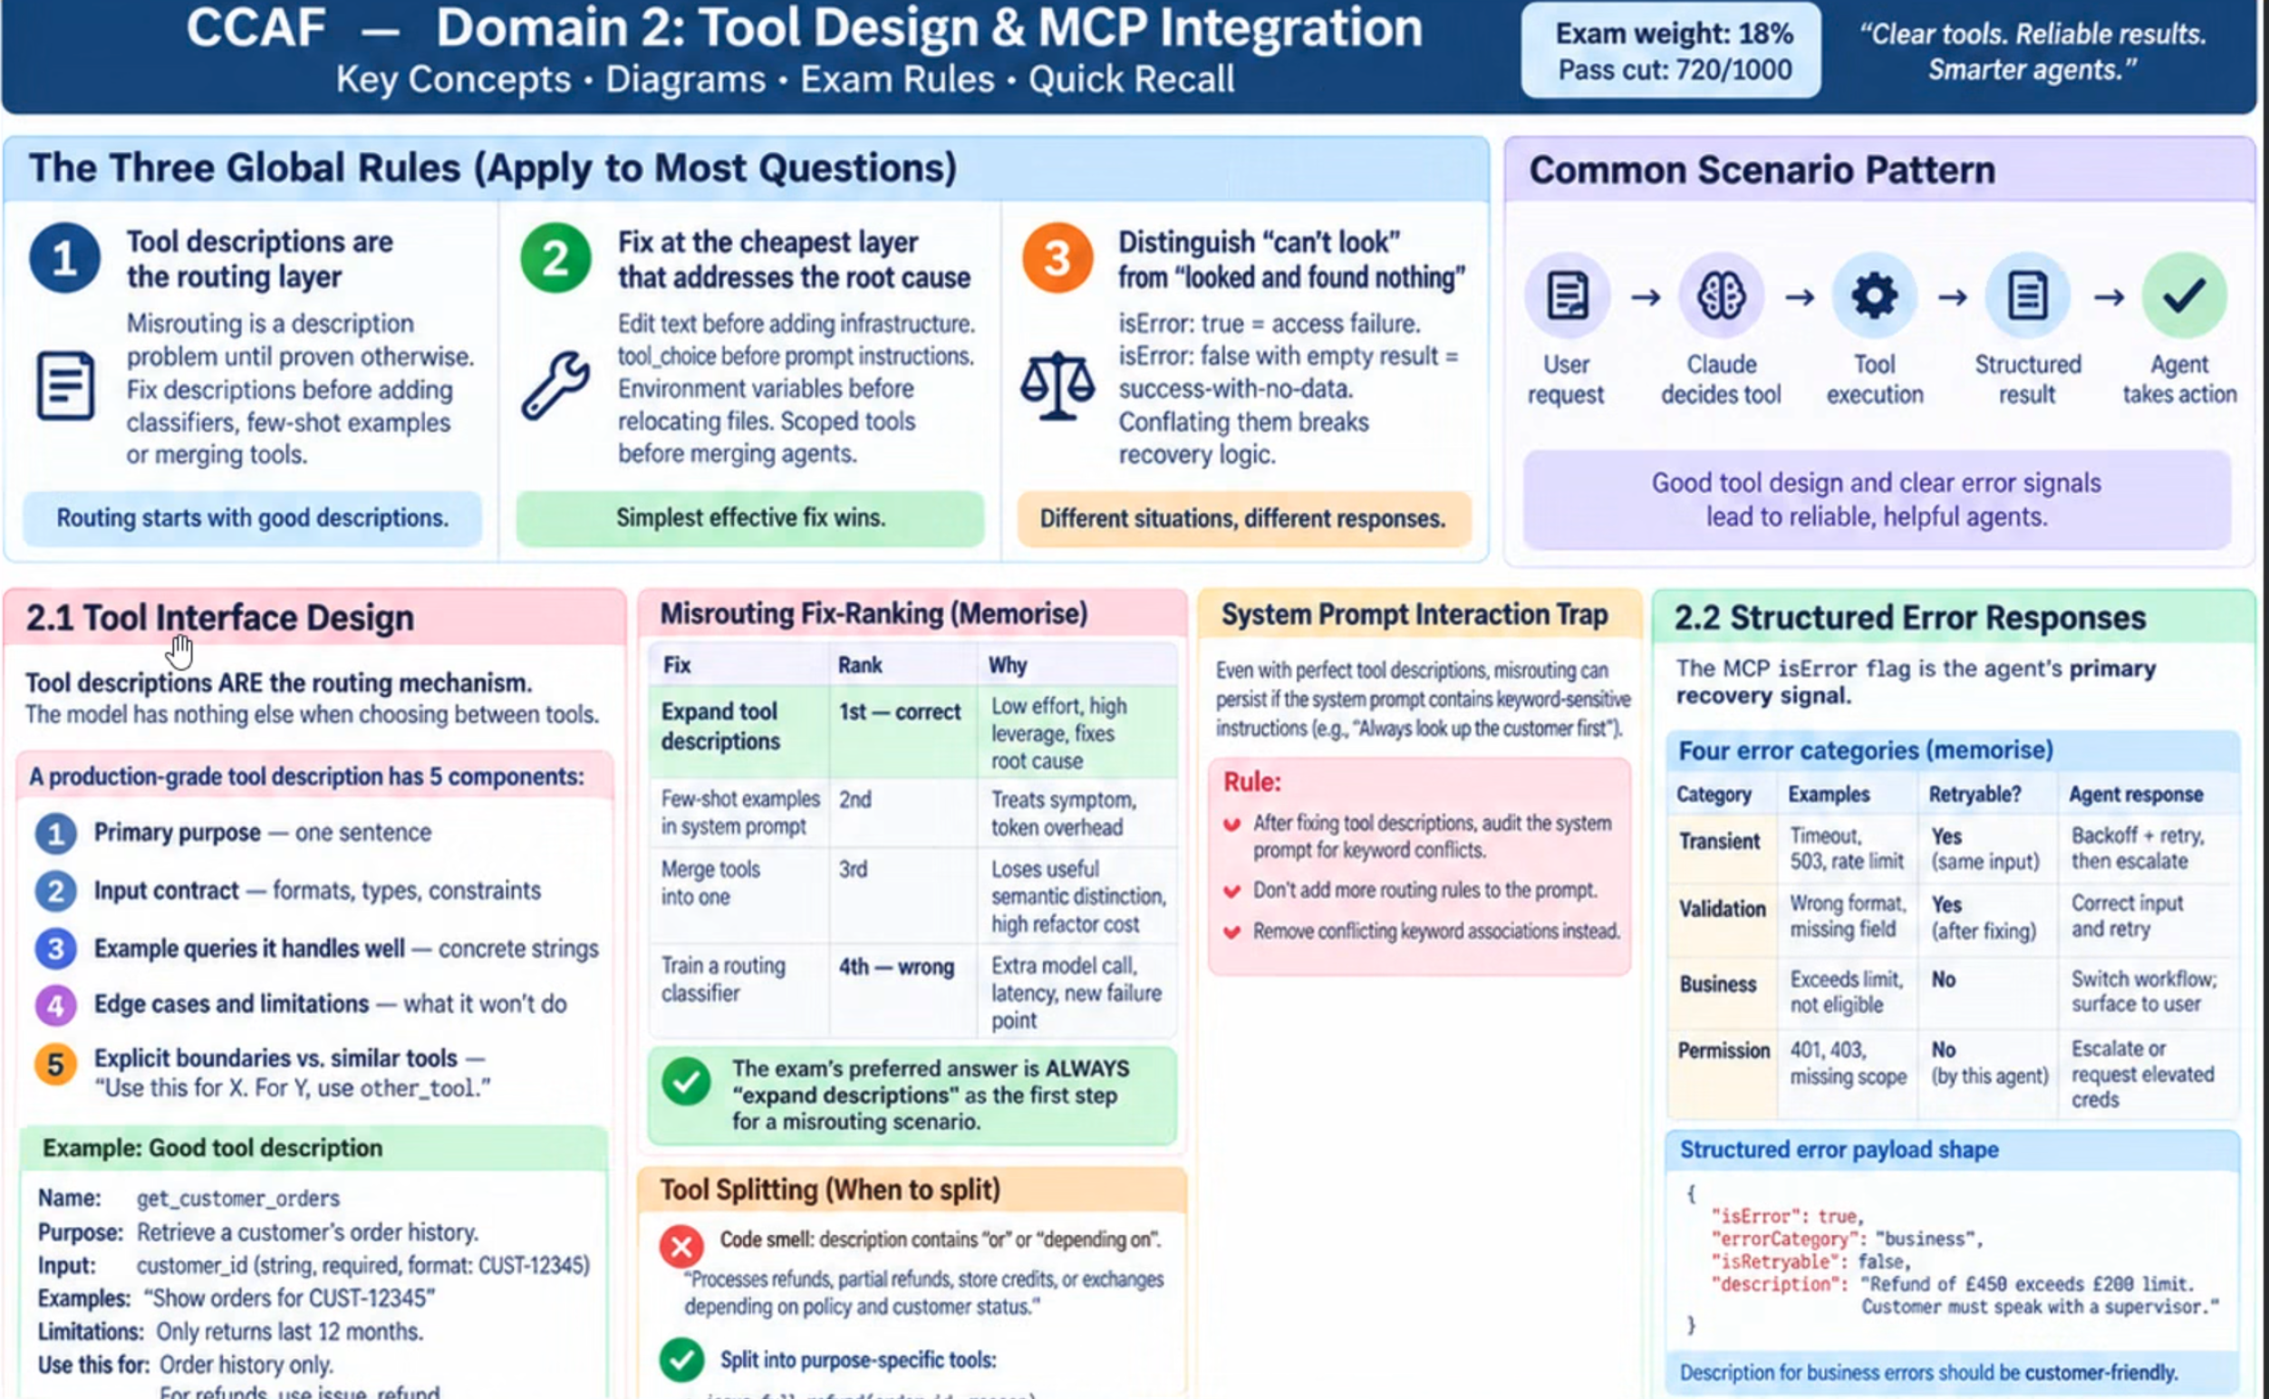

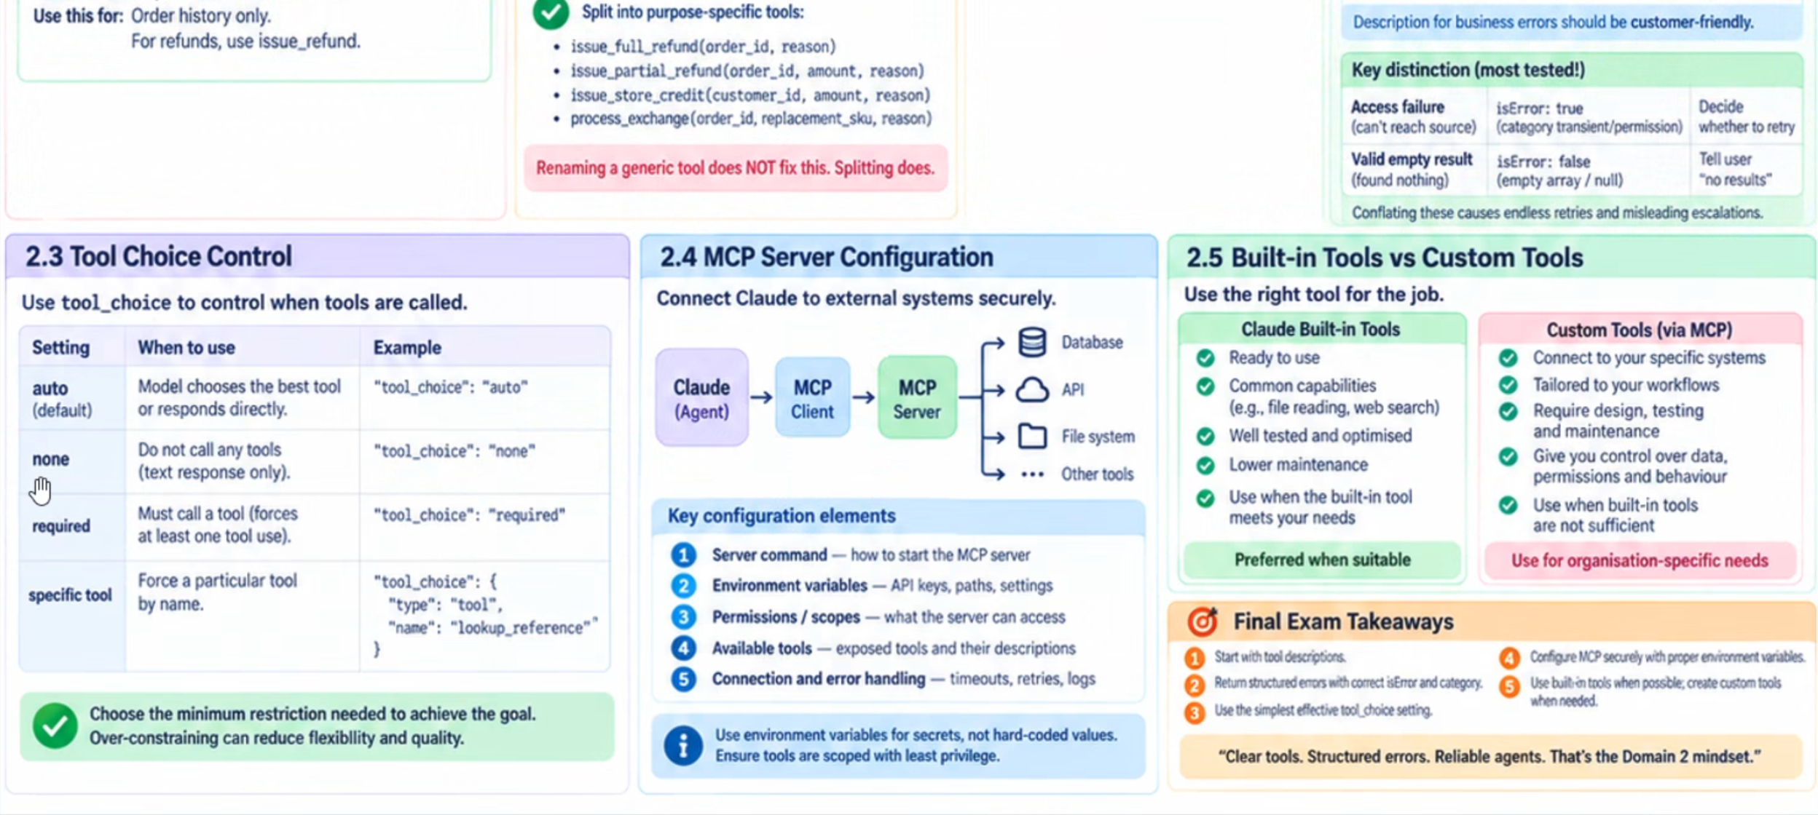

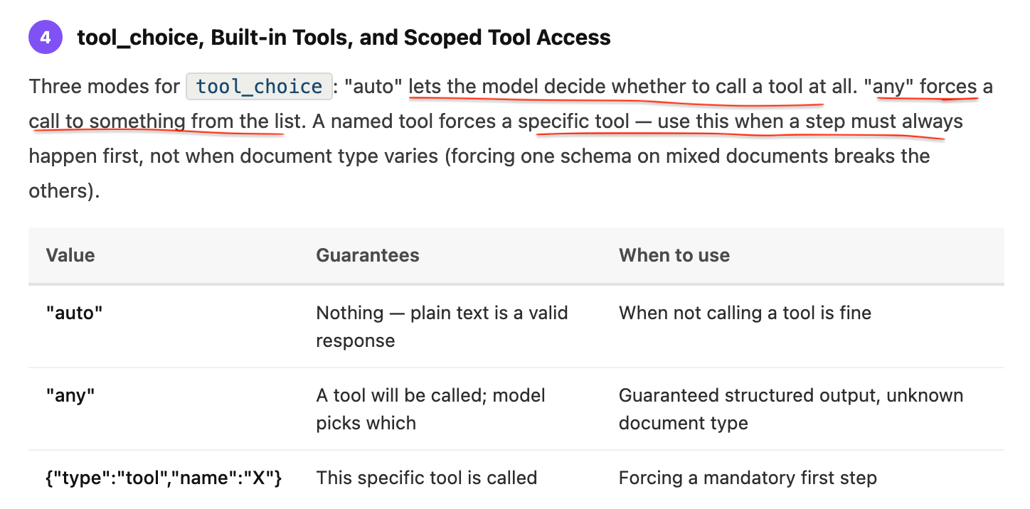

07Error handling and retries
errorCa  tegory | Examples | Retryable | Response
transient | Timeout, 429, 503 | yes | Retry with exponential backoff, bounded attempts
validation | Bad parameter, file not found | Yes (fix and try again) | Fix the input, then call again
permission | Unauthorised, password-protected | no | Report or escalate
business | Exceeds policy limit, no citations | no | Explain, or take another route
- Handle failures at the lowest level that can resolve them. Fallback parsers, skip-and-flag, retry budgets — inside the subagent or tool. Escalate only the unresolvable, with structured context and partial results.
- "No results" ≠ "access failed". An empty list is a success. A failed fetch is an error. Never let a failure look like an absence.
- Retryable ≠ safe to retry. Side-effecting calls need an idempotency key created once and reused on every attempt, with the server storing key → result.
Trap: a coordinator-level "retry 3 times on any failure". It repeats permanent errors, throws away completed work, and keeps the coordinator in the loop — the opposite of what an escalation-overload question wants.

08Multi-agent systems (Agent SDK)
coordinator ──┬── web-researcher (WebSearch, WebFetch)
├── document-analyst (doc tools only)
├── synthesizer (no tools)
└── report-writer (save_report)
- Context isolation: a subagent sees only its own prompt. Every delegation must be self-contained — topic, scope, time window, exclusions, return format.
- Parallelism comes from emitting several Task/Agent calls in one response. Separate turns = sequential. Not a flag, not allowedTools, not fork_session.
- Least privilege: scope tools per role. Agent drifting into web search ⇒ remove the tool.
- Structured handoffs: claim + source + excerpt. Summarising before the handoff is how citations get lost.
- Conflicts: keep both values with their sources and flag the conflict. Never silently pick or average.
- Coverage: map the domain before splitting, and compare the plan against the evidence before writing the report.
- Context budget: subagents return short findings, not raw pages.
Trap: all subagents succeed but whole areas are missing ⇒ the coordinator's decomposition was too narrow. Fix the plan, not the workers. Adding more narrow subtasks doesn't help.

import asyncio

# Conceptual Claude Agent SDK example.
# Exact SDK APIs can vary by version.

async def security_subagent():
"""
SUBAGENT 1
- Own isolated context
- Own system prompt
- Own tools
- Own model
"""

system_prompt = """
You are a Security Code Explorer.

Search the repository for authentication/security code.
Do NOT modify anything.

IMPORTANT:
Return ONLY relevant file names.
"""

tools = ["Glob", "Grep", "Read"]
model = "claude-sonnet"

# Imagine the Agent SDK executes this subagent here.
result = await run_agent(
prompt="Find files implementing authentication.",
system_prompt=system_prompt,
tools=tools,
model=model
)

return result

async def database_subagent():
"""
SUBAGENT 2
Has a SEPARATE context from security_subagent.
"""

system_prompt = """
You are a Database Code Explorer.

Find database access and repository files.
Do NOT modify anything.

Return ONLY relevant file names.
"""

tools = ["Glob", "Grep", "Read"]
model = "claude-haiku"

result = await run_agent(
prompt="Find files containing database access logic.",
system_prompt=system_prompt,
tools=tools,
model=model
)

return result

async def main_agent():

# Run independent subagents concurrently
security_files, database_files = await asyncio.gather(
security_subagent(),
database_subagent()
)

print("Security:", security_files)
print("Database:", database_files)

asyncio.run(main_agent())

For your CCAF exam, memorize this sentence:
Subagent = isolated context + specialized prompt + restricted tools + selectable model + distilled result back to parent. Independent subagents can run in parallel.

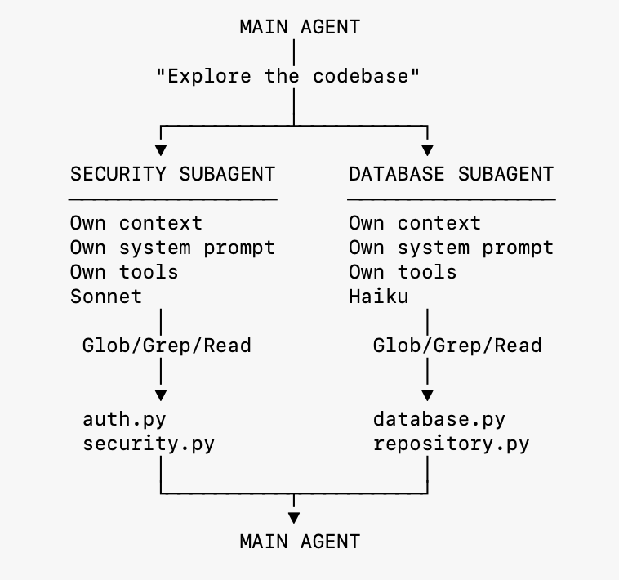

09Guarantees: hooks, permissions, budgets

Prompt vs hook
A prompt is probabilistic guidance. A hook is deterministic code. When a rule must hold — policy, security, routing — enforce it with a hook.
PreToolUse can allow, deny or rewrite a call; PostToolUse, SubagentStart/Stop give observability.

Headless safety
- tools = what exists; allowedTools = what runs without asking
- permission_mode: "dontAsk" denies anything unapproved
- max_turns, max_budget_usd bound runaway loops
- setting_sources: [] isolates from local settings

10Symptom → answer
The question says | The answer is
Report lacks citations; attribution lost | Structured handoffs pairing each claim with its source
All agents succeed, whole topics missing | Fix the coordinator's decomposition; add a coverage check
Research is slow | Several Task calls in a single response
Subagent doesn't know earlier findings | Put them in the delegation prompt — context isn't inherited
Agent using tools outside its role | Restrict its tool list
Excessive escalation for routine failures | Local recovery: fallbacks, skip-and-flag partials, escalate the rest
Customers charged twice after a timeout | Idempotency key, reused across retries
Wasted retries on permanent errors | errorCategory / isRetryable classification
Edit fails, anchor not unique | Widen the anchor; else replace_all; else Read + Write
Code changed since last session | New session + curated summary + note what changed
Preference needed in every chat | Account-wide instructions, set once
Live call, short rewording task | Haiku-class tier
Summary contains something unfamiliar | Check the attached source document yourself
Drafts overlap and don't map to sections | Split by the document's own sections

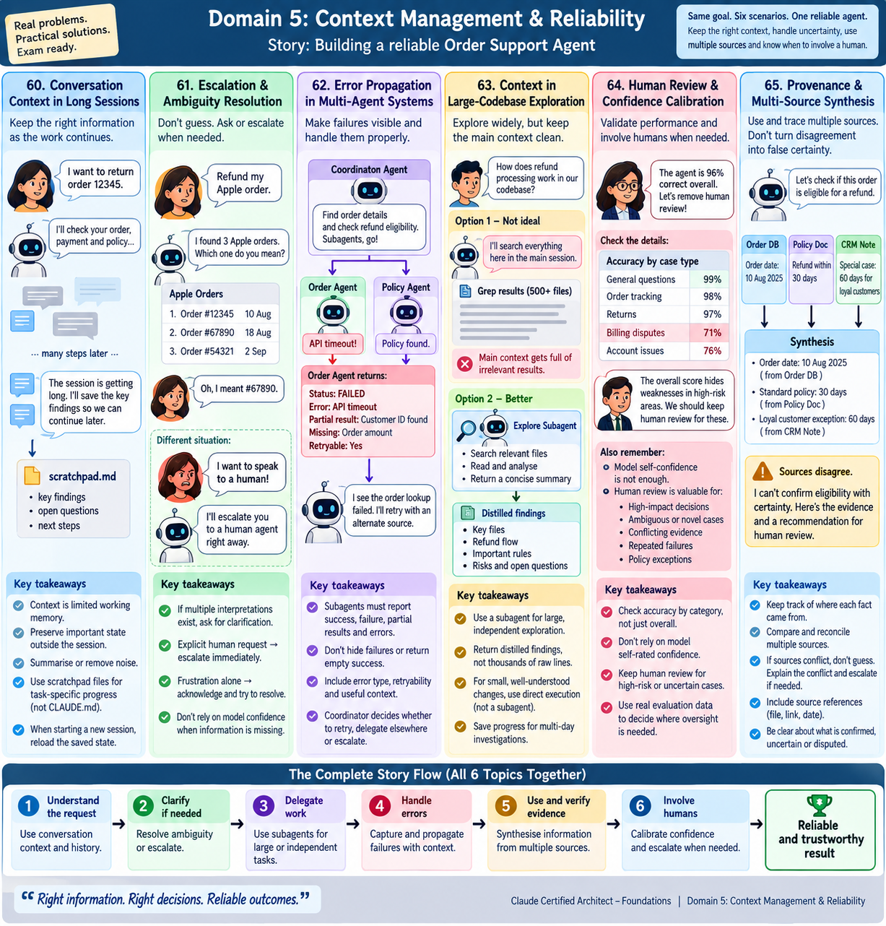

11Last-minute heuristics
- Prefer the smallest, most local fix that fully solves the stated problem.
- When several options "work", pick the one that addresses the symptom the question names (slow, escalation, duplicates, missing coverage).
- Distrust: retry everything at a higher level · prompt instructions where a mechanism is needed · prevent only the predictable subset · make the model police its own context.
- Failures should stay visible. Any option that hides a failure as an empty result is wrong.
- Partial results beat aborting the whole job.
plan before delegatingverify before reportingleast privilegeself-contained promptsclassify then retryidempotent writescurate context

Domain 1 — Section Review
Agentic Architecture & Orchestration
7/11
64% · Needs review · 4 missed
Q1 ✓ Correct
Production data shows that in 12% of cases, the support agent skips get_customer and calls process_refund directly using only the customer's stated name, occasionally leading to misidentified accounts and incorrect refunds. What change most reliably fixes this?
A
Strengthen the system prompt: "Customer verification via get_customer is mandatory before any order operation."
B
Add few-shot examples always showing get_customer called first, even when the customer volunteers an order ID.
C
Add a programmatic prerequisite that blocks lookup_order and process_refund until get_customer has returned a verified customer ID.
D
Deploy a routing classifier that analyses each request and enables only the appropriate tool subset.
Why C is correct:
Deterministic > probabilistic when stakes are real. Prompt instructions and few-shot examples have non-zero failure rates (~95–99%). When a wrong sequence causes financial harm, only programmatic enforcement (hooks or prerequisite gates) guarantees the ordering 100% of the time. Option D addresses tool availability, not tool ordering.
Q2 ✗ Incorrect
After running the system on the topic "impact of AI on creative industries," you observe that each subagent completes successfully: the web search agent finds relevant articles, the document analysis agent summarises papers correctly, and the synthesis agent produces coherent output. However, the final reports cover only visual arts, completely missing music, writing, and film production. When you examine the coordinator's logs, you see it decomposed the topic into three subtasks: "AI in digital art creation," "AI in graphic design," and "AI in photography." What is the most likely root cause?
A
The synthesis agent lacks instructions for identifying coverage gaps in the findings it receives from other agents.
B
The coordinator agent's task decomposition is too narrow, resulting in subagent assignments that don't cover all relevant domains of the topic.
C
The web search agent's queries are not comprehensive enough and need to be expanded to cover more creative industry sectors.
D
The document analysis agent is filtering out sources related to non-visual creative industries due to overly restrictive relevance criteria.
Why B is correct:
Trace failures to their origin. The coordinator's logs reveal the root cause directly — it decomposed 'creative industries' into only visual arts subtasks. The subagents executed their assigned tasks correctly; the problem is what they were assigned. Options A, C, and D incorrectly blame downstream agents that are working correctly within their (too-narrow) brief. Missing topics = coordinator decomposition problem.
Q3 ✓ Correct
When researching a broad topic, you observe that the web search agent and document analysis agent are both investigating the same subtopics, resulting in significant overlap in their findings. Token usage has nearly doubled without proportionally increasing the breadth or depth of research coverage. What is the most effective way to address this?
A
Give both agents identical tool sets and let the model naturally differentiate their outputs based on tool capabilities.
B
Merge the web search and document analysis agents into a single research agent to eliminate the coordination overhead.
C
Partition research scope in the coordinator's decomposition — assign distinct subtopics or source types to each agent to minimise duplication.
D
Add a deduplication pass where the synthesis agent filters out redundant findings after both agents complete.
Why C is correct:
Duplicate work = coordinator partitioning problem. The coordinator is responsible for partitioning research scope to minimise overlap — assigning distinct subtopics or source types (e.g., web search covers academic/news, document analysis covers uploaded PDFs). Merging agents (B) sacrifices useful specialisation. Deduplication (D) wastes tokens on work that was already redundant — fix upstream, not downstream.
Q4 ✓ Correct
A colleague suggests having the document analysis agent send its output directly to the synthesis agent instead of routing through the coordinator. What is the main advantage of keeping the coordinator as the central hub for all subagent communication?
A
It reduces coordinator involvement in routine data passing, decreasing overall latency.
B
The coordinator provides centralised observability, consistent error handling, and controlled information flow across the entire pipeline.
C
Direct communication allows subagents to share intermediate context the coordinator wouldn't otherwise see.
D
It prevents the synthesis agent from having to wait for the coordinator to reformat results before processing them.
Why B is correct:
Hub-and-spoke: all communication routes through the coordinator. Routing everything through the coordinator enables: (1) centralised observability — every message is logged and traceable, (2) consistent error handling — the coordinator decides recovery strategy, (3) controlled information flow — the coordinator decides what context each subagent receives. Direct subagent-to-subagent communication bypasses all three.
Q5 ✗ Incorrect
Your agent runs retries on transient API failures, but customers occasionally report being charged twice after a network timeout. Investigation shows the server processed the first request before the timeout. The retry then issued a second charge. Which fix addresses this completely?
A
Fix the backoff policy — longer delays between retries reduce duplicate processing on the server.
B
Add idempotency keys only — a unique key per operation prevents the server from processing the same request twice.
C
Fix the retry policy to classify errors before retrying — transient failures retry, permanent failures don't.
D
Both error classification AND idempotency keys are required — either alone is insufficient.
Why D is correct:
The paired-fix pattern. Error classification alone won't prevent duplicates if the server already processed a request before timing out. Idempotency keys alone won't help if a request that never reached the server is never retried. You need both: classify errors correctly so only safe retries happen, AND use idempotency keys so safe retries don't double-process. Generate a UUID/hash of {operation + customer + amount} on the first attempt.
Q6 ✓ Correct
To execute the web search subagent and document analysis subagent in parallel rather than sequentially, the coordinator must:
A
Use fork_session for each parallel branch before delegating.
B
Emit multiple Task tool calls across separate coordinator turns, one per subagent.
C
Emit multiple Task tool calls within a single coordinator response.
D
Set allowedTools to list all subagent type names simultaneously.
Why C is correct:
Parallel = multiple Task calls in one response. Emitting Task calls across separate turns means sequential execution — each turn waits for the prior. Parallel execution only happens when multiple Task tool calls appear in a single response. fork_session creates independent branches from a shared analysis baseline — useful for exploring divergent approaches, not for parallelising different agent types.
Q7 ✗ Incorrect
The document analysis subagent frequently encounters failures when processing PDF files — some have corrupted sections causing parsing exceptions, others are password-protected, and occasionally the parsing library times out on large files. Currently, any exception immediately terminates the subagent and returns an error to the coordinator, which must decide whether to retry, skip, or fail the entire task. This is causing excessive coordinator involvement in routine error handling. What's the most effective architectural improvement?
A
Add a coordinator-level retry policy that re-invokes the subagent up to 3 times for any document that fails.
B
Add detailed error-handling instructions to the subagent's system prompt so it classifies and responds to each failure type.
C
Pre-validate all PDF files before sending them to the subagent, rejecting password-protected or oversized files upfront.
D
Implement local error recovery within the subagent: try fallback parsers for corrupt sections, skip unrecoverable sections with a partial-result flag, and return structured error context only for truly unresolvable failures.
Why D is correct:
Local recovery within subagents — propagate only what can't be resolved locally. Transient and recoverable failures (corrupted sections, library timeouts) should be handled inside the subagent with fallbacks, partial results, and a flag indicating what was skipped. The coordinator should receive structured error context only for truly unresolvable failures. This eliminates excessive coordinator involvement in routine handling while preserving recovery information for complex cases. Coordinator-level retry (A) invokes the full subagent again on every failure — expensive and unnecessary for recoverable issues.
Q8 ✓ Correct
You've defined a coordinator agent with a system prompt instructing it to delegate research subtasks to specialized subagents. During testing, the coordinator produces detailed analysis but never delegates to any subagent — it handles everything itself. The most likely cause is:
A
The coordinator's system prompt doesn't explicitly name which subagents to invoke.
B
The subagent definitions don't have system prompts configured.
C
"Task" is not included in the coordinator's allowedTools configuration.
D
The coordinator needs more context about the research topic before it will decide to delegate.
Why C is correct:
allowedTools must include "Task" for a coordinator to spawn subagents. The Task tool is the mechanism for subagent invocation. Without it in allowedTools, the coordinator literally cannot call subagents regardless of what its system prompt says. This is a configuration requirement, not a prompting problem. Subagent system prompts (B) don't affect whether the coordinator can call them.
Q9 ✓ Correct
Your automated code review runs three steps on every PR: (1) analyze each file individually for local issues, (2) run a cross-file integration pass for data flow and contract issues, (3) generate a severity-ranked summary. The structure never varies. Which decomposition pattern is this, and is it the right choice?
A
Dynamic decomposition — appropriate because findings from step 1 could change what step 2 needs to examine.
B
Fixed sequential pipeline (prompt chaining) — appropriate because the structure is stable and each step consumes the prior step's output.
C
Evaluator-optimiser — appropriate because step 3 evaluates the quality of the prior steps.
D
Fixed sequential pipeline — but wrong; dynamic decomposition would skip unnecessary passes on simple PRs.
Why B is correct:
Fixed sequential pipeline for stable, predictable workflows. Prompt chaining is the right pattern when the structure doesn't need to adapt based on intermediate findings — each step consumes the prior step's output in a defined sequence. Dynamic decomposition adds overhead without benefit here since all three passes are always valuable regardless of PR content. Evaluator-optimiser (C) requires an objective quality signal to iterate against.
Q10 ✓ Correct
You want to explore two competing architectural approaches for the research pipeline — a sequential pipeline vs a parallel fan-out design — starting from the same codebase analysis you completed this morning. You need both explorations to stay independent so findings don't cross-contaminate. Which mechanism is designed for this?
A
Open two separate Claude Code terminal sessions and manually synchronize findings at the end.
B
Use --resume with two different session names, one per approach.
C
Use fork_session to create two independent branches from the shared analysis baseline.
D
Run two Task tool calls in a single coordinator response, one per approach.
Why C is correct:
fork_session creates independent exploration branches from a shared analysis baseline. Both branches start with the same codebase understanding; their findings don't contaminate each other. --resume (B) continues a session linearly — it doesn't branch. Two terminal sessions (A) don't share the prior analysis. Task tool calls (D) are for spawning subagents in a multi-agent system, not for branching your own exploration.
Q11 ✗ Incorrect
Last week you ran a deep codebase exploration session, mapping authentication flows and service boundaries. Since then, the team merged a major refactor of the auth module. You want to continue analysis using the prior findings. What's the most reliable approach?
A
Resume the prior session using --resume — it already has the full codebase map and tool results.
B
Start a new session and re-explore the entire codebase from scratch to avoid any stale assumptions.
C
Start a new session, inject a structured summary of the valid prior findings, and explicitly note that the auth module has changed.
D
Resume the prior session and instruct Claude to ignore its previous observations about the auth module.
Why C is correct:
New session + structured summary when prior tool results are stale. The auth module refactor means prior tool results for that area are stale — resuming imports them as if current. The reliable pattern: start fresh, inject a summary of findings that remain valid, and call out what changed so the new session investigates correctly. Resume is appropriate when prior context is mostly valid — here, a major refactor invalidates a key portion.
Next Section →


Domain 2 — Section Review
Tool Design & MCP Integration
4/7
57% · Study required · 3 missed
Q1 ✓ Correct
Production logs show the agent frequently calls get_customer when users ask about orders (e.g., "check my order #12345"), instead of lookup_order. Both tools have minimal descriptions ("Retrieves customer information" / "Retrieves order details") and accept similar identifier formats. What is the most effective first step to improve tool selection reliability?
A
Add few-shot examples to the system prompt demonstrating correct tool selection patterns, with 5–8 examples showing order-related queries routing to lookup_order.
B
Expand each tool's description to include input formats it handles, example queries, edge cases, and boundaries explaining when to use it versus similar tools.
C
Implement a routing layer that parses user input before each turn and pre-selects the appropriate tool based on detected keywords.
D
Consolidate both tools into a single lookup_entity tool that accepts any identifier and internally determines which backend to query.
Why B is correct:
Tool descriptions ARE the routing mechanism. Fix at the cheapest layer that addresses the root cause. Expanding descriptions is the highest-leverage first step — low effort, targets root cause directly. Few-shot examples (A) treat the symptom with added token overhead. A routing layer (C) is over-engineered. Consolidation (D) is a valid architecture but far more costly than a description edit.
Q2 ✓ Correct
Production logs reveal a consistent pattern: requests to "analyse the quarterly report I uploaded" are routed to the web search agent 45% of the time instead of the document analysis agent. Examining the tool definitions, you find the web search agent has an analyze_content tool described as "analyzes content and extracts key information," while the document analysis agent has an analyze_document tool described as "analyzes documents and extracts key information." How should you address this misrouting?
A
Add few-shot examples to the system prompt showing document analysis queries routed to the document analysis agent.
B
Rename analyze_content to extract_web_results and update its description to specify it handles web search results; update analyze_document to clarify it handles uploaded files, PDFs, and local documents.
C
Merge analyze_content and analyze_document into a single tool so the routing decision is eliminated.
D
Add a system prompt instruction: "Always route document upload requests to the document analysis agent."
Why B is correct:
Rename + describe to eliminate functional overlap. The near-identical descriptions ("analyzes content" vs "analyzes documents") are the root cause. The fix: rename analyze_content to extract_web_results and update both descriptions to specify input types, example queries, and explicit boundaries. Keyword instructions in the system prompt (D) compete with tool descriptions rather than fixing them. Merging (C) loses useful specialisation.
Q3 ✗ Incorrect
After expanding tool descriptions to fix misrouting, 30% of requests still route to the wrong tool. What should you investigate next?
A
Add 10–15 more few-shot examples until routing accuracy improves past 95%.
B
Audit the system prompt for keyword-sensitive instructions that create unintended tool associations — overriding the improved descriptions.
C
Merge the two tools to eliminate the routing decision entirely.
D
Deploy a dedicated routing classifier as a pre-processing step.
Why B is correct:
The system prompt keyword trap. Even with improved tool descriptions, a system prompt instruction like "Always look up the customer first" creates a keyword-tool association that overrides the descriptions. After fixing descriptions, audit the system prompt for conflicting instructions. The fix is to remove those associations — not add more routing rules that compete with descriptions.
Q4 ✓ Correct
During testing, you observe that the synthesis agent frequently needs to verify specific claims while combining findings. Currently, when verification is needed, the synthesis agent returns control to the coordinator, which invokes the web search agent, then re-invokes synthesis with results. This adds 2–3 round trips per task and increases latency by 40%. Your evaluation shows that 85% of these verifications are simple fact-checks (dates, names, statistics) while 15% require deeper investigation. What is the most effective approach to reduce overhead while maintaining system reliability?
A
Give the synthesis agent access to all web search tools so it can handle any verification need directly without round-trips through the coordinator.
B
Have the synthesis agent accumulate all verification needs and return them as a batch to the coordinator at the end of its pass, which then sends them all to the web search agent at once.
C
Give the synthesis agent a scoped verify_fact tool for simple lookups, while complex verifications continue delegating to the web search agent through the coordinator.
D
Have the web search agent proactively cache extra context around each source during initial research, anticipating what the synthesis agent might need to verify.
Why C is correct:
Principle of least privilege + proportionate fix. Give synthesis only what it needs for the 85% simple case via a scoped tool. The existing coordination pattern handles the 15% complex cases. Giving all web search tools (A) violates separation of concerns. Batching (B) creates blocking dependencies — synthesis steps may depend on earlier verified facts. Speculative caching (D) cannot reliably predict what will be needed.
Q5 ✗ Incorrect
An MCP tool returns {"isError": false, "results": []} when no papers are found. A different tool returns {"isError": true, "message": "Database timeout"} on a connectivity failure. A teammate proposes unifying both to {"status": "no_results"}. Why is this problematic?
A
The isError flag is required by the MCP specification and cannot be omitted.
B
Conflating an access failure with a valid empty result prevents the coordinator from knowing whether to retry — destroying recovery logic.
C
Agents always retry on isError:true, so unification would cause unnecessary retry loops.
D
The status field is not a recognised MCP response format.
Why B is correct:
isError:true means 'couldn't look.' isError:false + empty means 'looked, found nothing.' These require opposite coordinator responses: access failures → retry or escalate; valid empty results → continue with alternate approaches. Unifying them makes both look identical, destroying the recovery decision signal entirely.
Q6 ✓ Correct
You want to share an MCP server configuration with your entire team via version control, using an environment variable for the auth token. Correct configuration:
A
~/.claude.json with the token hardcoded, distributed via onboarding documentation.
B
.mcp.json in the project repository with ${GITHUB_TOKEN} environment variable expansion.
C
~/.claude/CLAUDE.md with an @import pointing to the MCP server config.
D
.claude/settings.json with the token stored as a CI/CD pipeline secret.
Why B is correct:
Project-level MCP = .mcp.json in the repo root. Version-controlled, available to all team members on clone/pull. Environment variable expansion (e.g., ${GITHUB_TOKEN}) handles credentials without committing secrets. ~/.claude.json is for personal/experimental servers — not shared via version control.
Q7 ✗ Incorrect
While helping a developer refactor a large utility file, Claude attempts to use the Edit tool to update a repeated helper pattern, but the edit fails — the anchor text appears dozens of times and is not unique. What's the correct recovery approach?
A
Use Grep to find all instances, then run Edit once per match using the surrounding lines as unique anchor text.
B
Use Bash with sed to perform a global search-and-replace across the file.
C
Use Read to load the full file contents, apply all modifications, then use Write to save the complete updated file.
D
Use Glob to identify all files containing the pattern and edit them one at a time.
Why C is correct:
When Edit fails due to non-unique anchor text, the fallback is Read + Write. Load the full file, apply all changes in memory, write it back completely. This is reliable regardless of how many times the pattern appears. Multiple Edit calls (A) still fail when the surrounding context is also repeated. sed via Bash (B) works but bypasses the intended tooling. Glob (D) matches file paths by pattern — it's not a content-modification tool.

